MODULE 3
— Loops and repeated computation
QUES 1. CODE:
#include <stdio.h>

int main() {
int a, b;
scanf("%d %d", &a, &b);

for (int i = a; i <= b; i++) {

if (i == 1) {
printf("one\n");
}
else if (i == 2) {
printf("two\n");
}
else if (i == 3) {
printf("three\n");
}
else if (i == 4) {
printf("four\n");
}
else if (i == 5) {
printf("five\n");
}
else if (i == 6) {
printf("six\n");
}
else if (i == 7) {
printf("seven\n");
}
else if (i == 8) {
printf("eight\n");
}
else if (i == 9) {
printf("nine\n");
}
else if (i % 2 == 0) {
printf("even\n");
}
else {
printf("odd\n");
}
}

return 0;
}
SCREENSHOT:
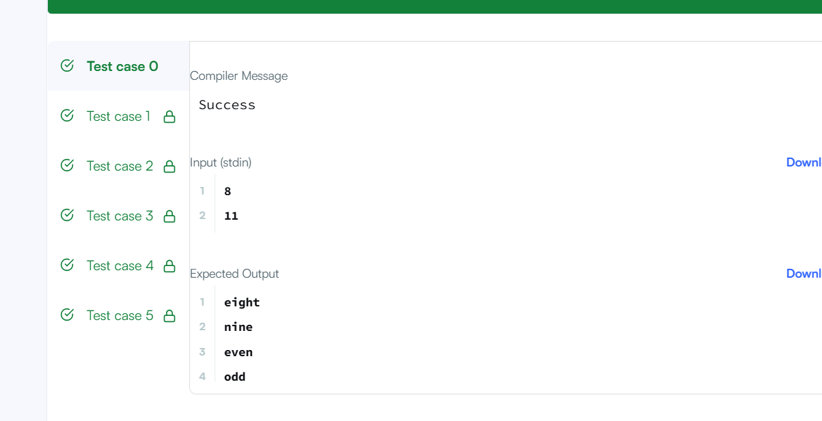
URL: https://www.hackerrank.com/challenges/for-loop-in-c/problem
QUES2. CODE:
int numberOfSteps(int num) {
int count = 0;

while (num > 0) {
if (num % 2 == 0) {
num = num / 2;
}
else {
num = num - 1;
}

count++;
}

return count;
}
SCREENSHOT:
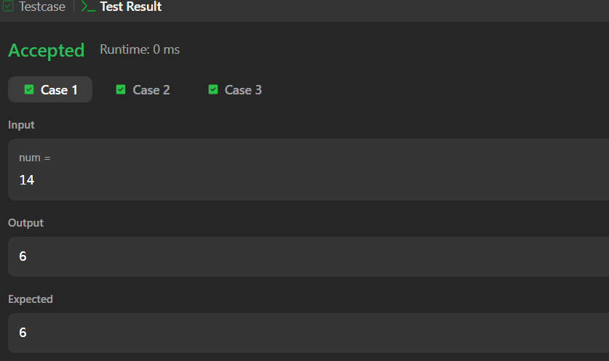

URL: https://leetcode.com/problems/number-of-steps-to-reduce-a-number-to-zero/submissions/2192389577/
QUES 3. CODE:
int countOperations(int num1, int num2) {
int count = 0;

while (num1 != 0 && num2 != 0) {
if (num1 >= num2) {
num1 = num1 - num2;
}
else {
num2 = num2 - num1;
}

count++;
}

return count;
}
SCREENSHOT:
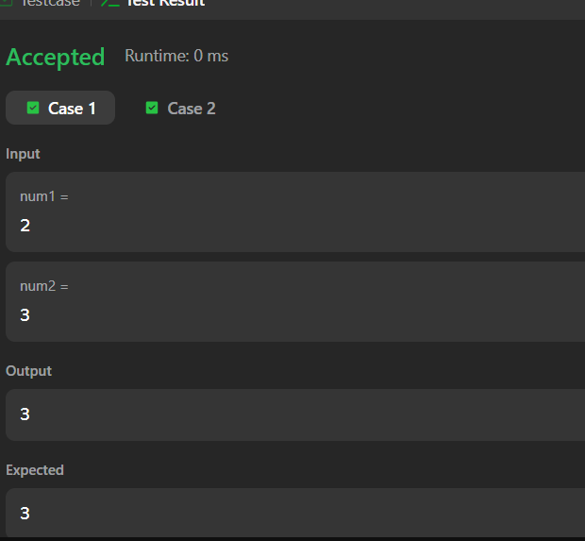
URL: https://leetcode.com/problems/count-operations-to-obtain-zero/

QUES4. CODE:
int countOdds(int low, int high) {
int count = 0;

for (int i = low; i <= high; i++) {
if (i % 2 != 0) {
count++;
}
}

return count;
}
SCREENSHOT:
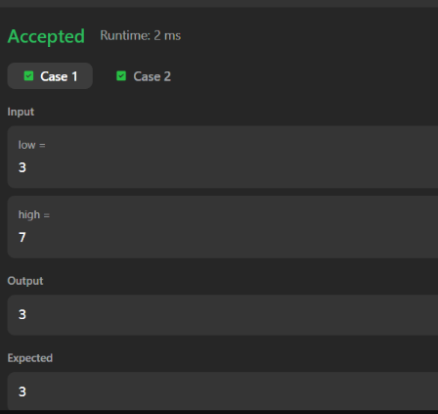
URL: https://leetcode.com/problems/count-odd-numbers-in-an-interval-range/
QUES5. CODE:
int sumOfMultiples(int n) {
int sum = 0;
for (int i = 1; i <= n; i++) {
if (i % 3 == 0 || i % 5 == 0 || i % 7 == 0) {
sum = sum + i;
}
}

return sum;
}
SCREENSHOT:
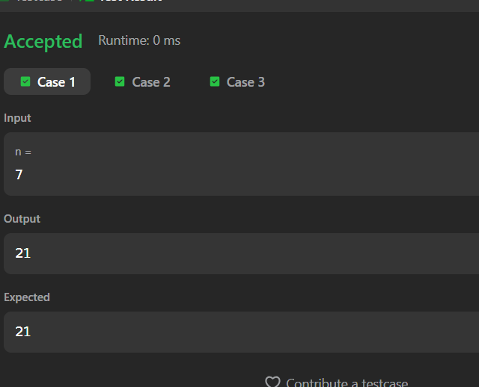
URL: https://leetcode.com/problems/sum-multiples/submissions/2192394307/
QUES6. CODE:
#include <stdio.h>

int main() {
int x1, v1, x2, v2;

scanf("%d %d %d %d", &x1, &v1, &x2, &v2);

if (v1 > v2 && (x2 - x1) % (v1 - v2) == 0) {
printf("YES");
}
else {
printf("NO");
}

return 0;
}
SCREENSHOT:
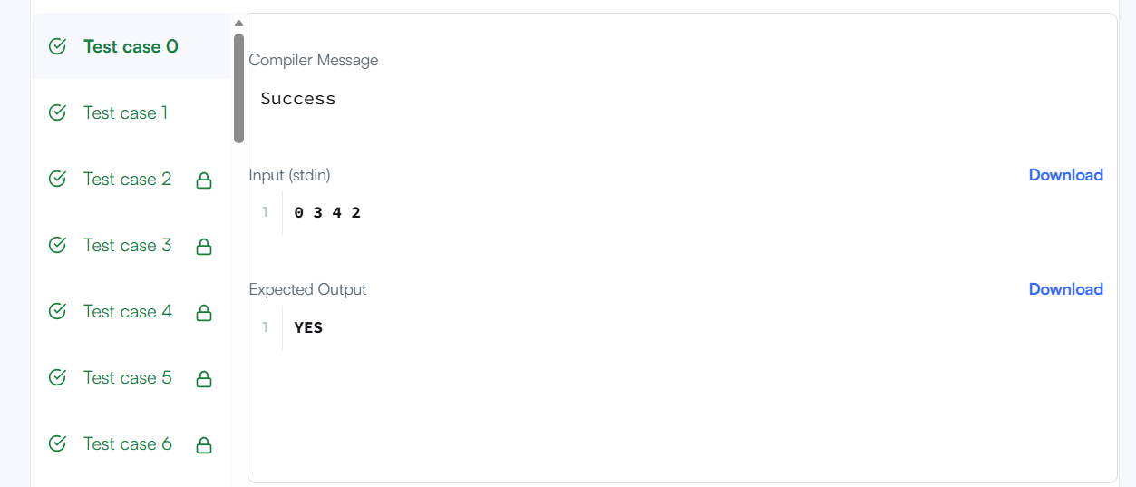
URL: https://www.hackerrank.com/challenges/kangaroo/problem

